Fact about moon :

Earth has only one moon, a rocky, cratered place about a quarter the size of Earth and an average distance of 238,855 miles. The moon can be seen with the naked eye most nights as it traces its 27-day orbit around our planet.he also has 14 days night and 14  day

How did the moon form:

A lot of scientists believe that the moon was formed by the impact of the earth and another asteroid who has the size of planet Mars .With the help of gravity the debris formed the moon

What do we know about moon :

we know that the Moon is covered in craters, dust and debris from comets, asteroids and meteorite impacts. We know that the dark areas of the moon called Maria, which is Latin for seas, are not actually seas. Instead, they are craters that lava seeped into billions of years ago. We know that the moon has almost no atmosphere and only about a sixth of Earth's gravity. We even know that quite a bit of frozen water is hidden in craters near the lunar pole

Source

:https://spaceplace.nasa.gov/all-about-the-moon/en/

Taking the Moon’s Temperature:

Daytime temperatures near the lunar equator reach a boiling 250 degrees Fahrenheit (120 °C, 400 K), while nighttime temperatures reach a chilly -208 degrees Fahrenheit (-130 °C, 140 K). The lunar poles are even colder. Diviner even found a spot on the moon's Hermite Crater floor measured at -250°C, 25K, making it the coldest temperature recorded anywhere in the solar system! Extremely cold regions, similar to those in Hermite Crater, have been found at the bottom of several permanently shadowed craters at the Moon's south pole and measured in the depths of the winter night

Source

<https://www.google.com/url?sa=t&source=web&rct=j&url=https://lunar.gsfc.nasa.gov/images/lithos/LROlitho7temperaturevariation27May2014.pdf&ved=2ahUKEwi2592w3-_7AhVsiP0HHYCoD6UQFnoECAwQBg&usg=AOvVaw0tXBczFYUfcDmqshjXk4KF>

***What metal is found on the lunar surface?***

|  |  |
| --- | --- |
| Iron | Iron (Fe) is abundant in all mare basalts (~14-17% per weight) but is mostly locked into silicate minerals (i.e. pyroxene and olivine) and into the oxide mineral ilmenite in the lowlands. Extraction would be quite energy-demanding, but some prominent lunar magnetic anomalies are suspected as being due to surviving Fe-rich meteoritic debris. Only further exploration in situ will determine whether or not this interpretation is correct, and how exploitable such meteoritic debris may be. |
| Titanium | [Titanium](https://en.wikipedia.org/wiki/Titanium) can be alloyed with iron, [aluminium](https://en.wikipedia.org/wiki/Aluminium" \o "Aluminium), [vanadium](https://en.wikipedia.org/wiki/Vanadium), and [molybdenum](https://en.wikipedia.org/wiki/Molybdenum" \o "Molybdenum), among other elements, to produce strong, lightweight alloys for aerospace. It exists almost entirely in the mineral [ilmenite](https://en.wikipedia.org/wiki/Ilmenite" \o "Ilmenite) (FeTiO3) in the range of 5-8% by weight.[[1]](https://en.wikipedia.org/wiki/Lunar_resources" \l "cite_note-Crawford_2015_review-1) Ilmenite minerals also trap hydrogen (protons) from the [solar wind](https://en.wikipedia.org/wiki/Solar_wind" \o "Solar wind), so that processing of ilmenite will also produce hydrogen, a valuable element on the Moon.[[46]](https://en.wikipedia.org/wiki/Lunar_resources" \l "cite_note-anorthite-46) The vast flood basalts on the northwest nearside ([Mare Tranquillitatis](https://en.wikipedia.org/wiki/Mare_Tranquillitatis" \o "Mare Tranquillitatis)) possess some of the highest titanium contents on the Moon,[[35]](https://en.wikipedia.org/wiki/Lunar_resources" \l "cite_note-Gruener_2019-35) harboring 10 times as much titanium as rocks on Earth do |
| Aluminum | [Aluminum](https://en.wikipedia.org/wiki/Aluminum) (Al) is found with a concentration in the range of 10-18% by weight, present in a mineral called [anorthite](https://en.wikipedia.org/wiki/Anorthite" \o "Anorthite)  , the calcium endmember of the [plagioclase](https://en.wikipedia.org/wiki/Plagioclase" \o "Plagioclase) feldspar mineral series.[[1]](https://en.wikipedia.org/wiki/Lunar_resources" \l "cite_note-Crawford_2015_review-1) Aluminum is a good [electrical conductor](https://en.wikipedia.org/wiki/Electrical_conductor" \o "Electrical conductor), and atomized aluminum powder also makes a good solid rocket fuel when burned with oxygen. Extraction of aluminum would also require breaking down [plagioclase](https://en.wikipedia.org/wiki/Plagioclase" \o "Plagioclase) |
| Silicon | [Silicon](https://en.wikipedia.org/wiki/Silicon) (Si) is an abundant metalloid in all lunar material, with a concentration of about 20% by weight. It is of enormous importance to produce [solar panel arrays](https://en.wikipedia.org/wiki/Photovoltaic_system" \o "Photovoltaic system) for the conversion of sunlight into electricity, as well as glass, fiber glass, and a variety of useful ceramics. Achieving a very high purity for use as semi-conductor would be challenging, especially in the lunar environment. |
| Calcium | [Calcium](https://en.wikipedia.org/wiki/Calcium) (Ca) is the fourth most abundant element in the lunar highlands, present in [anorthite](https://en.wikipedia.org/wiki/Anorthite" \o "Anorthite) mineral Calcium oxides and calcium silicates are not only useful for ceramics, but pure calcium metal is flexible and an excellent [electrical conductor](https://en.wikipedia.org/wiki/Electrical_conductor" \o "Electrical conductor) in the absence of oxygen. Anorthite is rare on the Earthbut abundant on the Moon Calcium can also be used to fabricate silicon-based [solar cells](https://en.wikipedia.org/wiki/Solar_cell" \o "Solar cell), requiring lunar silicon, iron, titanium oxide, calcium and aluminum. |
| Magnesium | [Magnesium](https://en.wikipedia.org/wiki/Magnesium) (Mg) is present in magmas and in the lunar minerals [pyroxene](https://en.wikipedia.org/wiki/Pyroxene" \o "Pyroxene) and [olivine](https://en.wikipedia.org/wiki/Olivine) so it is suspected that magnesium is more abundant in the lower lunar crust. Magnesium has multiple uses as [alloys](https://en.wikipedia.org/wiki/Alloy" \o "Alloy) for aerospace, automotive and electronics. |

# The Chemical Composition of Lunar Soil

#### As a lunar geochemist I have been approached many times by people who believe that they have a sample from the Moon. Common stories are (something like) “This dust was given to my late grandfather by astronaut Buzz Lightyear” or “This rock that I found in my petunia pot looks just like lunar meteorite [QUE 94281](https://sites.wustl.edu/meteoritesite/items/lm_que_94281/) on your website.” Lately, people have been sending me reports that they have obtained of chemical analyses from labs or one of those [hand-held x-ray “guns.”](https://sites.wustl.edu/meteoritesite/items/meteorite-testing/" \l "XRF) So, here is what you need to know in order to interpret those reports.

### Major Elements – In lunar rocks and soils 99% of the mass consists of the following 7 chemical elements

**Oxygen (41-45%) | [Silicon (Si)](https://sites.wustl.edu/meteoritesite/items/the-chemical-composition-of-lunar-soil/" \l "Si) | Aluminum (Al) | [Calcium (Ca)](https://sites.wustl.edu/meteoritesite/items/the-chemical-composition-of-lunar-soil/" \l "Ca)**  
**[Iron (Fe)](https://sites.wustl.edu/meteoritesite/items/the-chemical-composition-of-lunar-soil/" \l "Fe) |**[**Magnesium (Mg)**](https://sites.wustl.edu/meteoritesite/items/the-chemical-composition-of-lunar-soil/#Mg)**|**[**Titanium (Ti)**](https://sites.wustl.edu/meteoritesite/items/the-chemical-composition-of-lunar-soil/#Ti)

[**Fe/Mn**](https://sites.wustl.edu/meteoritesite/items/the-chemical-composition-of-lunar-soil/#FeMn)**|**[**Ca/Al**](https://sites.wustl.edu/meteoritesite/items/the-chemical-composition-of-lunar-soil/#CaAl)

### **Minor Elements** – Nearly all of the remaining 1% consists to these 4 chemical elements

[**Manganese (Mn)**](https://sites.wustl.edu/meteoritesite/items/the-chemical-composition-of-lunar-soil/#Mn)**|**[**Sodium (Na)**](https://sites.wustl.edu/meteoritesite/items/the-chemical-composition-of-lunar-soil/#Na)**|**[**Potassium (K)**](https://sites.wustl.edu/meteoritesite/items/the-chemical-composition-of-lunar-soil/#K)**|**[**Phosphorus (P)**](https://sites.wustl.edu/meteoritesite/items/the-chemical-composition-of-lunar-soil/#P)

#### Below are charts I have made from data from dozens of literature sources and my own lab for what we geochemists call the “major elements” and “minor elements” in samples from the 6 Apollo mission and 3 Russian Luna missions that brought samples back from the Moon. To make it simple, I have stuck to just soil (regolith) samples. I have also included data for those lunar meteorites that are breccias because many to most of these rocks are composed of lithified soil. The lunar meteorites come from all over the Moon whereas the Apollo and Luna mission all come a small area of the nearside.

#### In rocks of the Earth and Moon, oxygen is the most abundant chemical element, 41-45% on the Moon. Practically nobody actually measures the concentration of oxygen in rocks anymore. We measure the “metals” like iron and aluminum.

#### Terrestrial geochemists like to “express” the measured concentration of, say, silicon “as the oxide.” They measure the concentration of Si and state the concentration as the SiO2. So, [10.0 % Si is 21.4% SiO](http://meteorites.wustl.edu/goodstuff/oxides.htm)[2](http://meteorites.wustl.edu/goodstuff/oxides.htm). Quartz is a form SiO2, but quartz is rare on the Moon. Nearly all (>99%) lunar Si is in the silicate minerals plagioclase, pyroxene, and olivine. Likewise, there is no actual MgO (the mineral periclase) on the Moon; magnesium is carried mostly by the minerals pyroxene and olivine. We express the metal concentrations as oxide concentrations because the sum of 10 major and minor metal oxides above should be 100±1%. If not, something wrong (!) as there are no (= insignificant amounts of) carbonates, sulfates, or hydrous (water-bearing) minerals on the Moon. Lunar meteorites, however, often to contain carbonates, sulfates, or hydrous minerals as a result of weathering on Earth after they land.

#### So, for geochemists, the bottom and left axes of the plots below are in weight-percent oxide. For scrap-yard dealers and jewelers who might have an x-ray gun set to the “metal” setting, use the top and right axes.

#### All the plots have aluminum concentrations on the horizontal axis. I do it that way because Al varies over a large range in lunar samples. (To confuse you, [elsewhere here](https://sites.wustl.edu/meteoritesite/items/how-do-we-know-that-its-a-rock-from-the-moon/) I have put FeO+MgO on the horizontal axis, but that is OK because there is a strong [anticorrelation](https://sites.wustl.edu/meteoritesite/items/how-do-we-know-that-its-a-rock-from-the-moon/" \l "Anticorrelation) between Al2O3 and FeO+MgO in lunar samples.)

#### Finally, in the plots below, each point for Apollo 11, and the 3 Luna missions represents a chemical analysis. For example, nearly all the Apollo 11 points represent soil sample [10084](https://curator.jsc.nasa.gov/lunar/lsc/10084.pdf), which is probably the most well characterized geologic sample ever analyzed. For Apollos 12, 14, 15, 16, and 17, each point represents a numbered soil sample (“surface” and “trench” soils, no cores), e.g., samples 12032, 14163, 15071, 65701, and 76501 (mean of all available analyses for each). The large spread for some of these missions reflect the compositional variation among the various locations at which samples were collected at the site. For the lunar meteorites, each point represents a named stone, e.g., MacAlpine Hills 88105 or Northwest Africa 8046 and its pairs. For reference, each plot also includes an “Earth” point, which is an average of 4 different estimates I found in the literature for the mean composition of upper continental crust of the Earth.

## Silicon (Si)

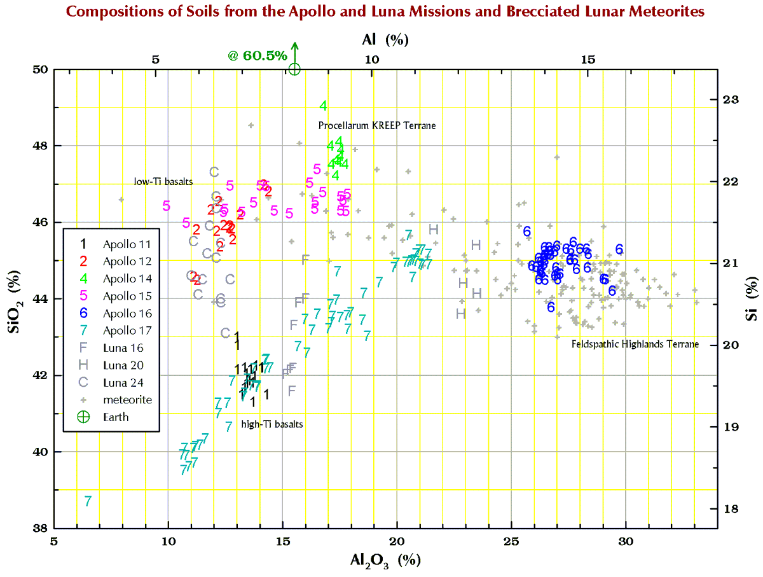**On Earth, [SiO](http://meteorites.wustl.edu/goodstuff/oxides.htm)[2](http://meteorites.wustl.edu/goodstuff/oxides.htm) concentrations in rocks vary from 0% to 100%. The variation on the Moon is much less because the 3 major minerals in lunar rocks, plagioclase feldspar (usually anorthite), pyroxene, and olivine, all have about the same [SiO](http://meteorites.wustl.edu/goodstuff/oxides.htm)[2](http://meteorites.wustl.edu/goodstuff/oxides.htm) concentration.**

## Iron (Fe)

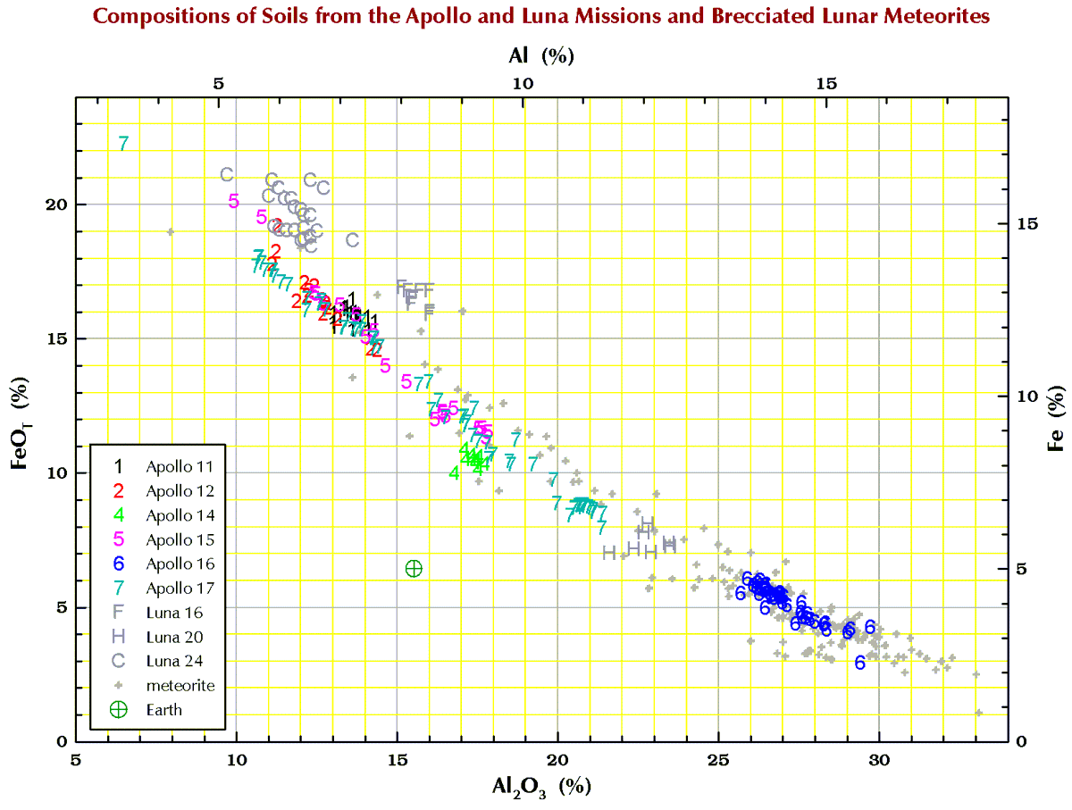**On Earth, iron exists in the 2+ (ferrous) and 3+ (ferric) oxidation states so in chemical analysis of rocks, Fe concentrations are usually stated as % Fe2O3 because the ferric oxidation state is more common than ferrous oxidation state. On the Moon there is (effectively) no oxygen-bearing atmosphere so there are no iron 3+ iron minerals. The iron in pyroxene, olivine, and iron-titanium minerals like ilmenite is all in the ferrous (2+) oxidation state. To complicate the issue, some of the iron in every lunar soil exists as metal. Up to 10% of the iron in some of these sample is metallic, usually as iron-nickel metal derived from meteorites. So, in analyses of lunar samples, results for iron are usually stated as “total Fe as FeO” or FeOT. The anticorrelation in this plot occurs because soils on the left (basaltic) are dominated by the Al-poor, Fe-rich minerals pyroxene, olivine, and ilmenite whereas those on the right (feldspathic) are dominated by the Al-rich, Fe-poor mineral plagioclase.**

## Manganese (Mn)

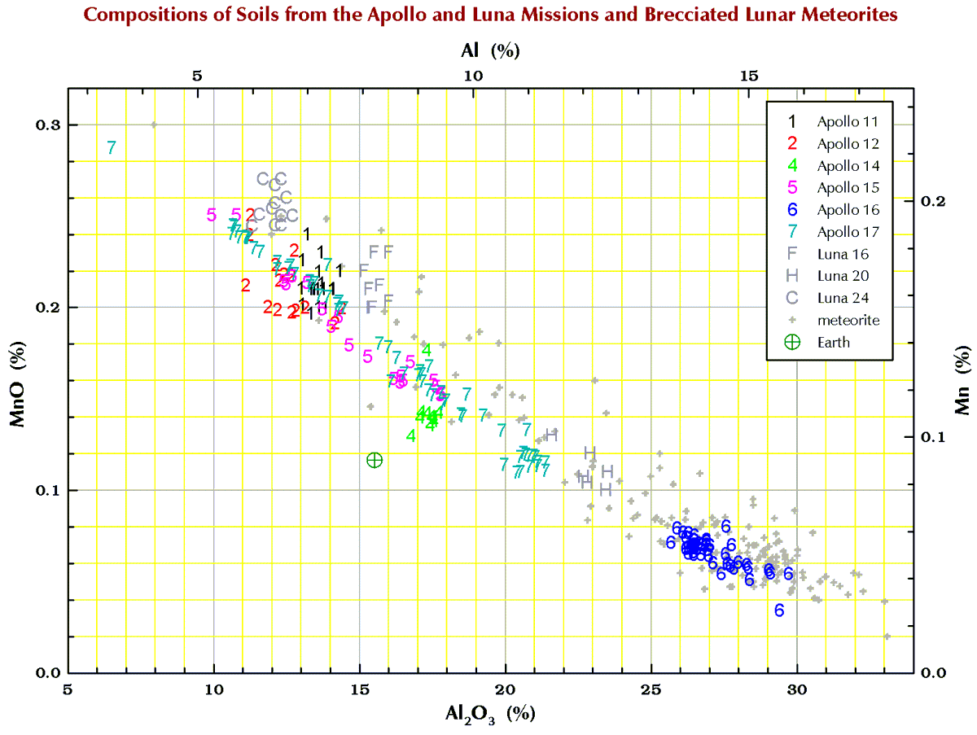**On the Moon, all the Mn is in the 2+ oxidation state so it “behaves” just like 2+ Fe.**

## Iron/Manganese (Fe/Mn)

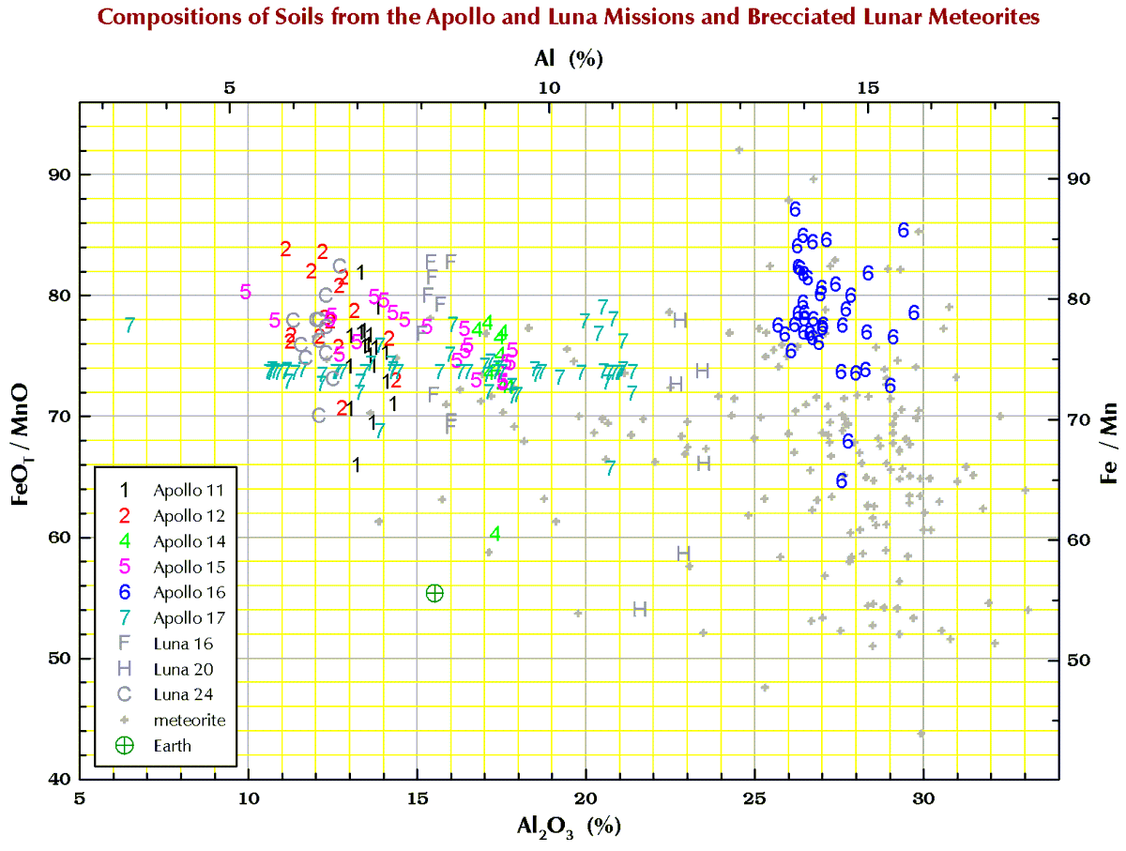**On the Moon, all the Mn is in the 2+ oxidation state so out “behaves” just like 2+ Fe. As a result, Fe/Mn ratios of lunar samples are rather constant in the 60-90 range. This characteristic is useful for distinguishing lunar meteorites from other types of meteorites but is often not useful for distinguishing lunar meteorites from terrestrial rocks**.

## Magnesium (Mg)

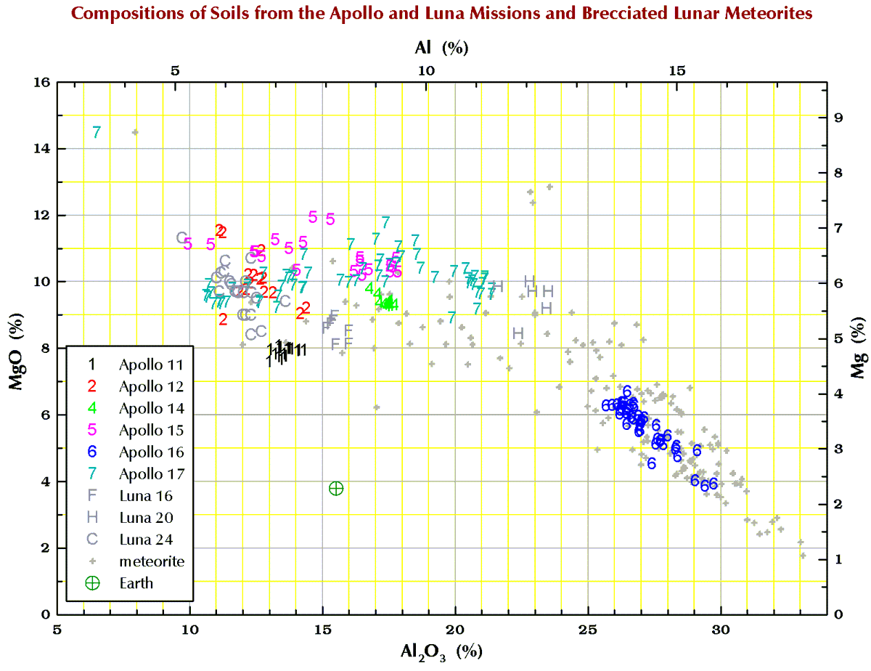**Most of what is said above for 2+ Fe is also true for magnesium. In lunar rocks, nearly all the Mg is in pyroxene and olivine.**

## Calcium (Ca)

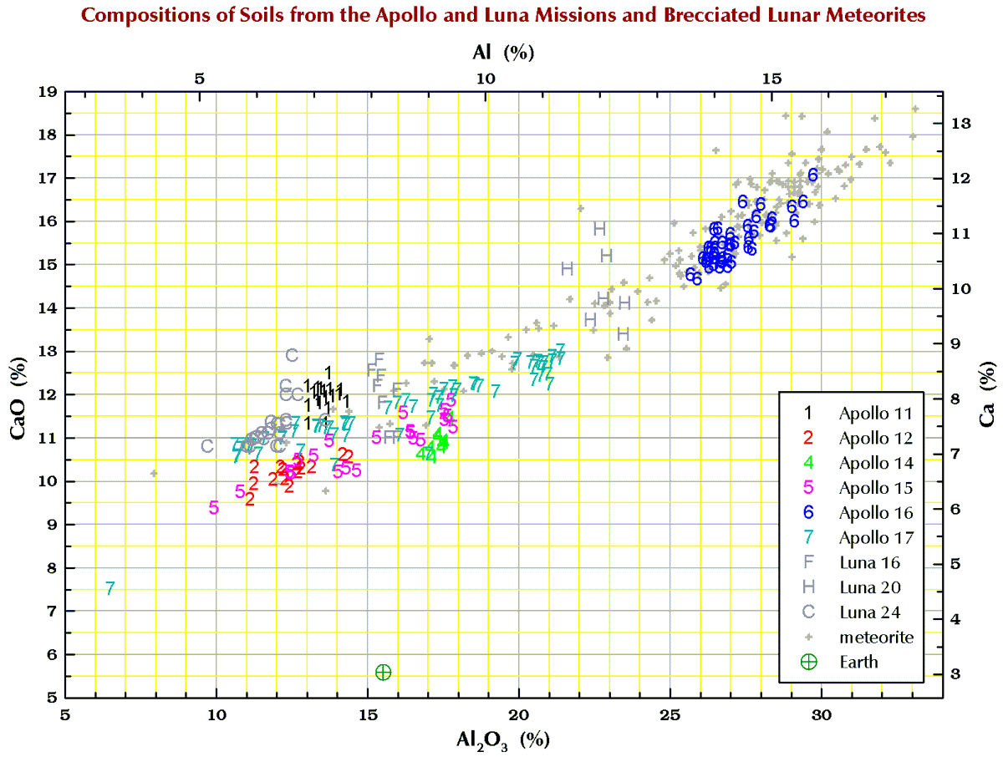**For Al-poor rocks, some of the Ca is in clinopyroxene but on the Moon most of the Ca is in plagioclase (anorthite), which is also the main host for aluminum. Thus, the two elements strongly correlate.**

## Calcium Aluminum (Ca/Al)

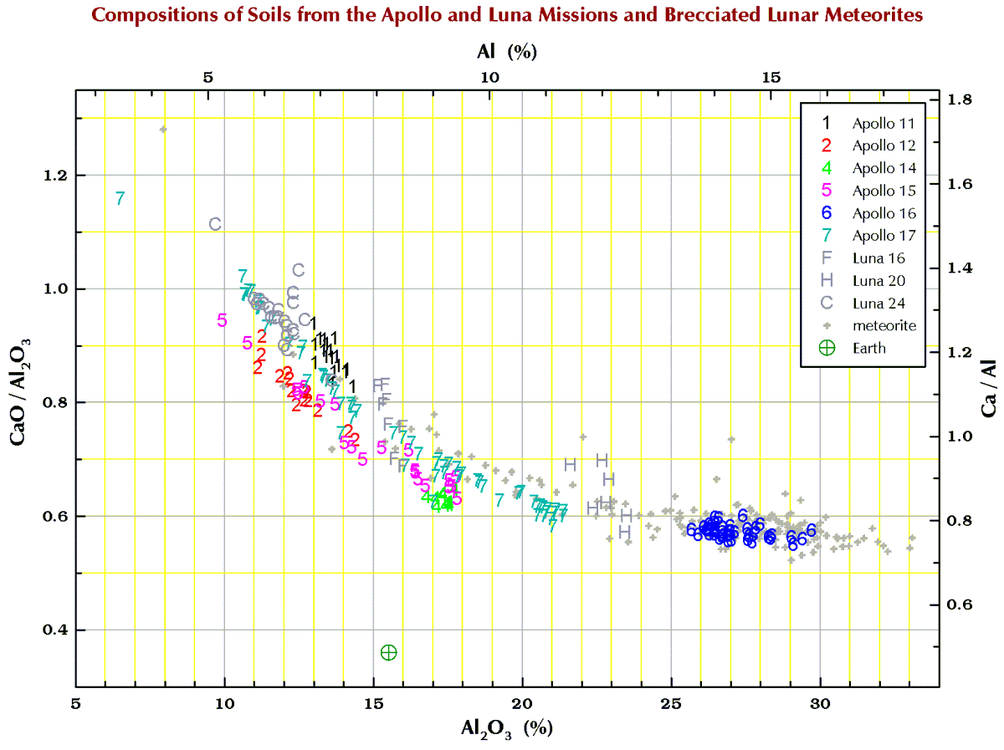**The Ca/Al ratio in lunar samples varies by only a factor of 2. The few high-Ca meteorites are contaminated with terrestrial calcite.**

## Titanium (Ti)

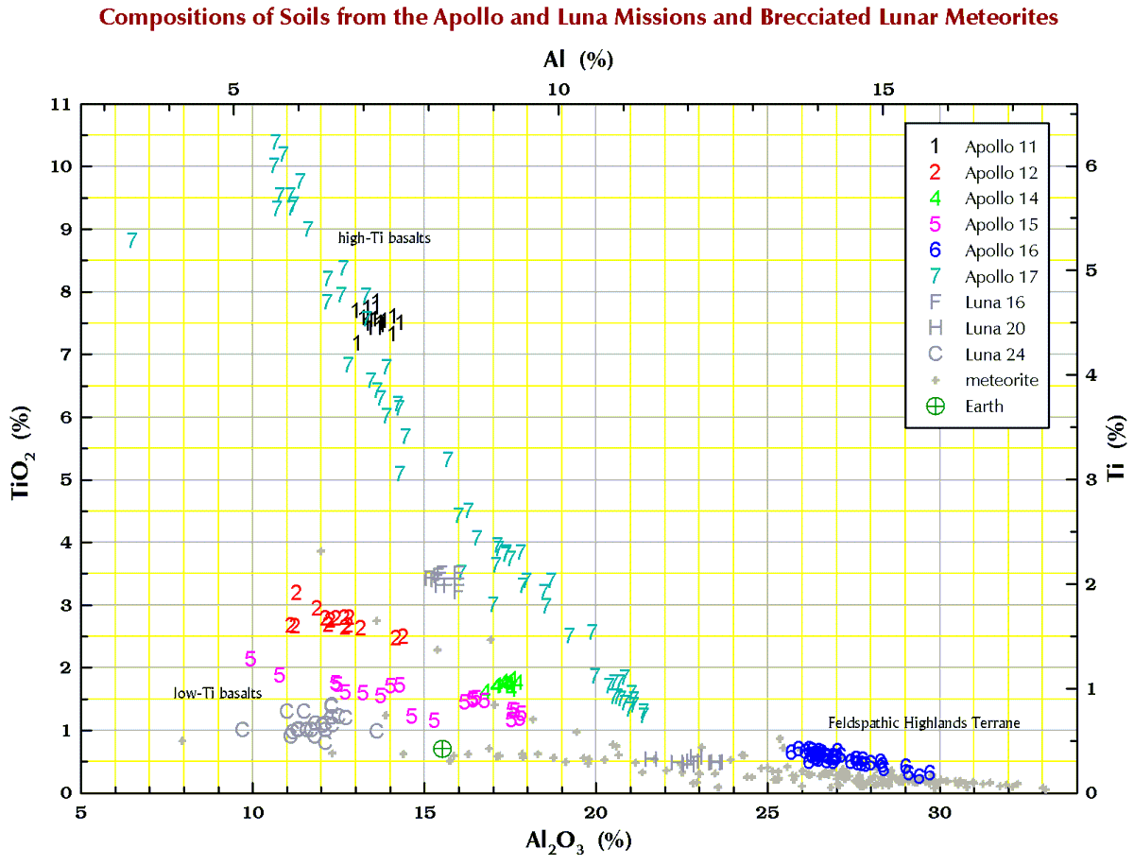**Concentrations of Ti vary by a factor of 10 in basaltic lunar soils.**

## Chromium (Cr)

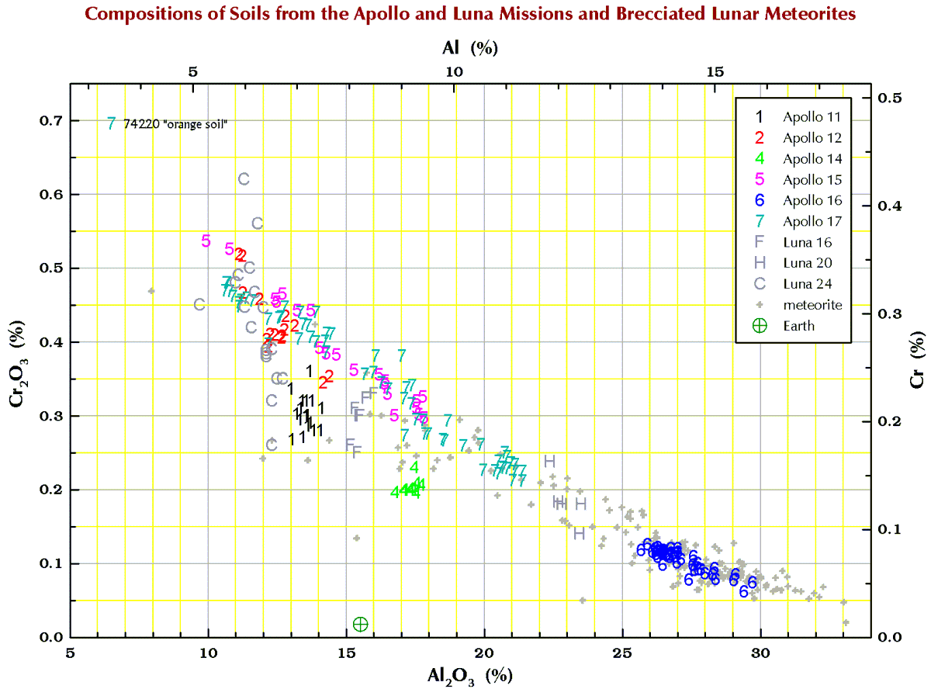**Cr concentrations in lunar samples are much higher than they are in nearly all terrestrial samples. Cr is one of the best elements for**[**distinguishing between lunar and terrestrial samples**](https://sites.wustl.edu/meteoritesite/items/chemical-composition-of-meteorites/)**.**

## Sodium (Na)

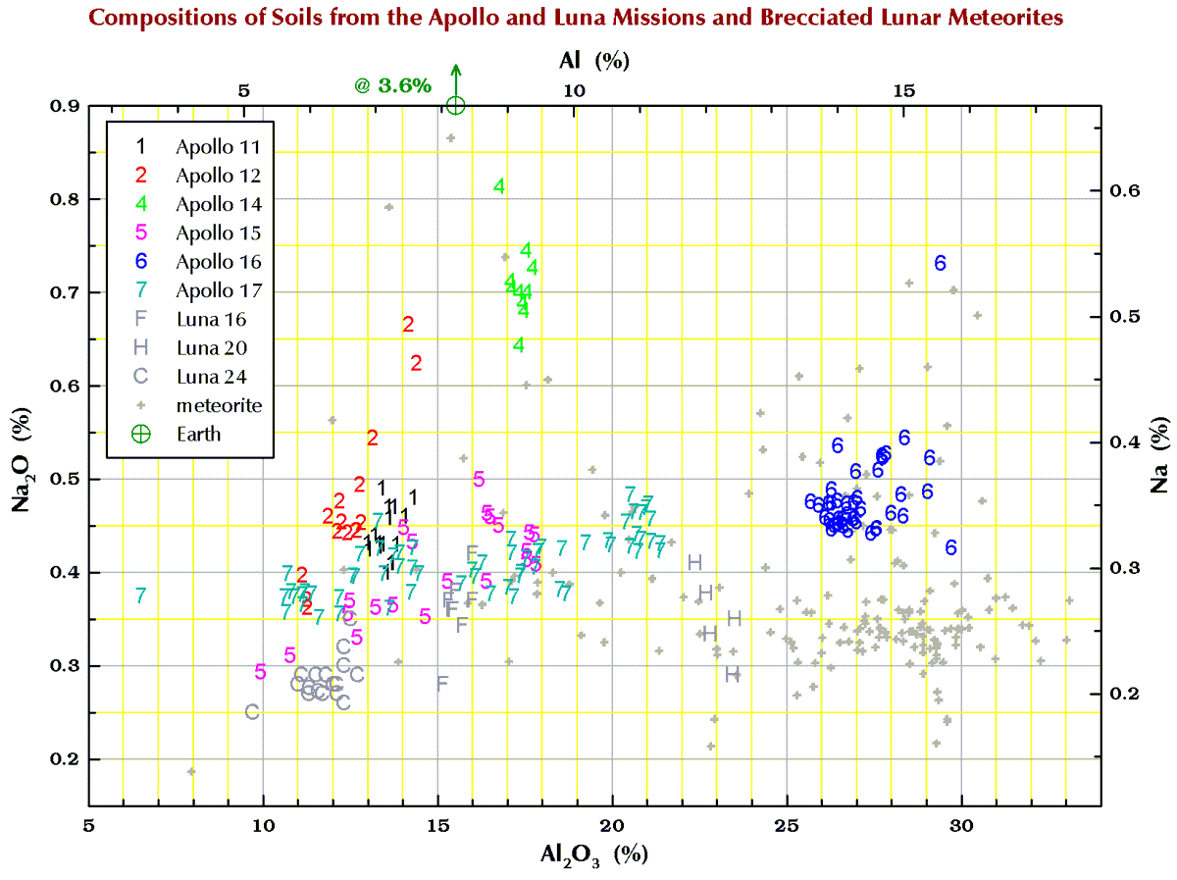**Na concentrations in lunar samples are much lower than they are in most terrestrial samples. Na is an element that is often good for**[**distinguishing between lunar and terrestrial samples**](https://sites.wustl.edu/meteoritesite/items/chemical-composition-of-meteorites/)**.**

## Potassium (K)

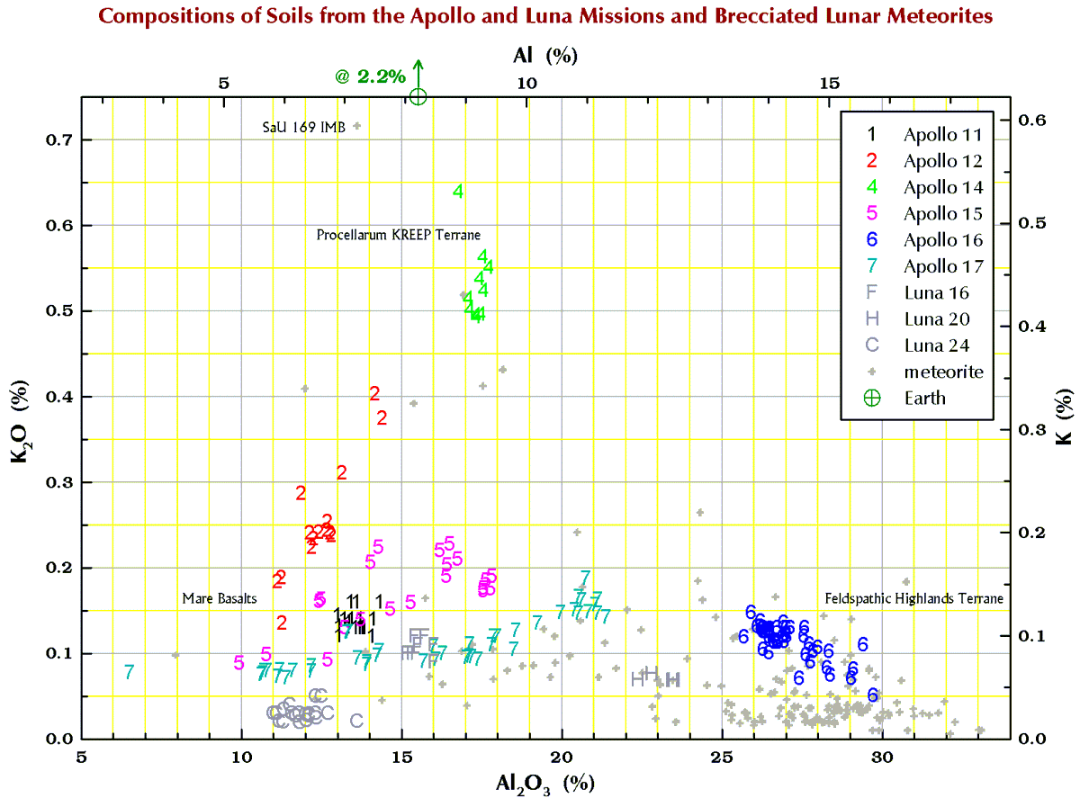**Like Na, K concentrations in lunar samples are much lower than they are in most terrestrial samples. Potassium is an element that is often good for**[**distinguishing between lunar and terrestrial samples**](https://sites.wustl.edu/meteoritesite/items/chemical-composition-of-meteorites/)**.**

## Phosphorus (P)

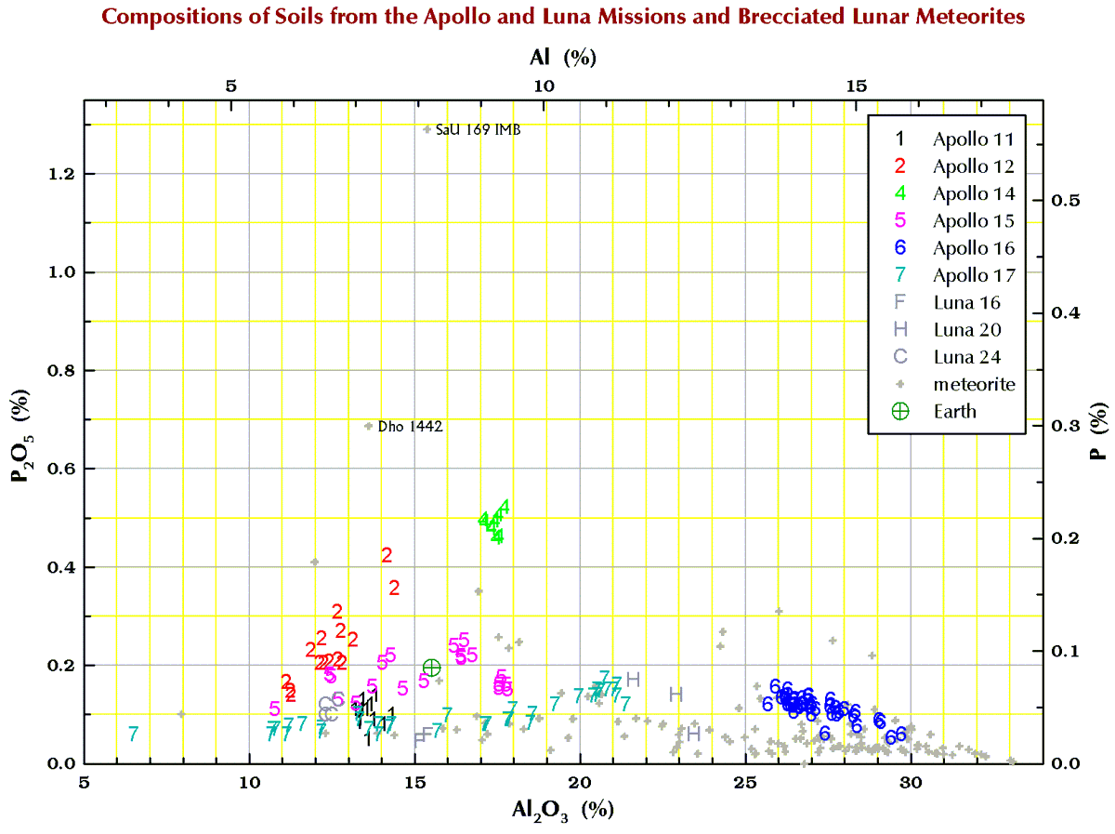**Phosphorus in not particularly useful for distinguishing between lunar and terrestrial samples.**

What is the necessary elements in the soil to plant?

Soil is a major source of nutrients needed by plants for growth. The three main nutrients are **nitrogen (N), phosphorus (P) and potassium (K)**. Together they make up the trio known as NPK. Other important nutrients are calcium, magnesium and sulfur.

https://www.dpi.nsw.gov.au/agriculture/soils/soil-testing-and-analysis/plant-nutrients#:~:text=Soil%20is%20a%20major%20source,are%20calcium%2C%20magnesium%20and%20sulfur.

Can we farm on the moon?

**Farming on the Moon could become a reality sooner rather than later**. Scientists have for the first time successfully grown plants in the Moon's soil. This lunar soil, also called regolith, was brought to Earth from the Moon by the Apollo-era astronauts.

https://www.indiatoday.in/science/story/scientists-grow-plants-lunar-dirt-moon-1948847-2022-05-13

What is the moon’s regolith ?

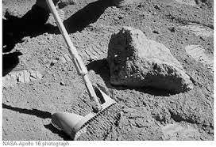

Lunar regolith is a loose mixture ofdust, soil, broken rockand other related materials that lie on top of solid bedrock. TheApollo-eraresearch showed that returned lunar samples of the regolith did nothave toxinsor contain alien life-form contaminants that could threaten plants,animals orhumans on Earth.

https://www.space.com/8843-space-farms-minerals-moon-dirt.html

Can we plant with the moon’s regolith ?

The lunardust and regolith contained certain elements useful for plant growth,such asiron, magnesium and manganese, even if it **mostly lacked necessaryelements suchas nitrogen, phosphorus, sulfur and potassium**

**https://www.space.com/8843-space-farms-minerals-moon-dirt.html**

NASA is learning how to farm on the moon:

* NASA and the German space agency are investing in space agricultural projects, with testing in regions like Antarctica, that could potentially support habitats beyond Earth.
* Innovations from previous NASA projects have helped advance the agricultural industry, including the vertical farming system that has now developed into a multi-billion-dollar industry, and includes companies like Square Roots, founded by Elon Musk’s brother Kimbal Musk.
* https://www.cnbc.com/2021/06/20/space-agencies-are-learning-how-to-farm-on-mars-and-the-moon.html

Ice in the south pole :

At the southern pole , most of the ice is concentrated at Lunar craters , with enough ice sitting at the surface water would possibly be accessible as resource for futur expédition to explore and even on the moon

(https://www.nasa.gov/feature/ames/ice-confirmed-at-the-moon-s-poles )

These reservoirs, which have been forming over eons, could be truly gigantic, and would provide enough water ice for astronauts to survive and thrive, sustaining humans on the moon. "Lunar water" can be divided into oxygen and hydrogen, which are essential elements for rocket fuel ,not to mention the production of potable water.

The lunar water could also serve as a source of oxygen, another vital material not readily found on the Moon, and hydrogen, which could be used as rocket fuel. Paul Spudis, one of the scientists who took part in the Clementine study, referred to the lunar ice deposit as possibly "the most valuable piece of real estate in the solar system". It appears that in addition to the permanently shadowed areas there are some higher areas such as crater rims which are permanently exposed to sunlight and could serve as a source of power for future missions. (https://nssdc.gsfc.nasa.gov/planetary/ice/ice\_moon.html)

How we can practice agriculture on moon :

NASA has developed a vegetable production system aboard the International Space Station called "Veggie", which is a unit the size of a suitcase that usually contains 6 different types of plants. The seeds are attached to small sticks using natural guar gum, and placed inside bags called pillows. Each pillow contains a growth medium of calcined clay and compost. These media help fou the distribution of water, nutrients and air around the roots in appropriate quantities, so that they do not sink into the apict. LED produces light  
  
  
Source :   
https://www.nasa.gov/content/veggie-plant-growth-system-activated-on-international-space-station

How would the extraction work?

While the moon is rich in metals, they are bound in the rocks as oxides of metals and oxygen that stick together. This is where astrometallurgy comes in, which is simply the study of extracting metal from space rocks. Metallurgists use a variety of methods to separate metals and oxygen from rock. Some of the more common extraction methods use chemicals like hydrogen and carbon. Some, like electrolytic separation, use pure electricity, while more novel solutions completely vaporize the rock to make metal. If you are interested in a full summary of astrometallurgy on the moon, you can read about it in one of my research papers

Source :

https://theconversation.com/artemis-1-is-off-and-were-a-step-closer-to-using-moon-dirt-for-construction-in-space-191852